# Lakeflow Spark Declarative Pipelines

* Here, we will talk about lake flow declarative pipelines.
* We will understand what the **lake flow declarative pipeline framework** is and how it differs from Apache Spark.
* We will also learn about these object types and how to define them in both SQL and Python syntax.
* Lake Flow Declarative Pipelines, or LDP, is a new ETL framework for building reliable and maintainable data processing pipelines.
* It is based on Apache Spark but uses a declarative approach for developing pipelines.It means you just define the desired outcome of data transformations without managing the execution details.
* So LDP abstracts the complexity of building large scale pipelines.
* LDP, previously known as Delta Live Tables or DLT, was originally a proprietary Databricks product, but Databricks has recently open sourced this solution, integrating it into the Apache Spark ecosystem under the name **Spark Declarative Pipelines**.
* Here we see a screenshot of the pipeline that we are going to build in the hands on. This shows our tables and views and the dependencies between them. This processing flow or order of execution will be automatically visualized from the source code of our pipeline. This automatic orchestration, which automatically maintains stable dependencies, is one of the advantages of LDP.

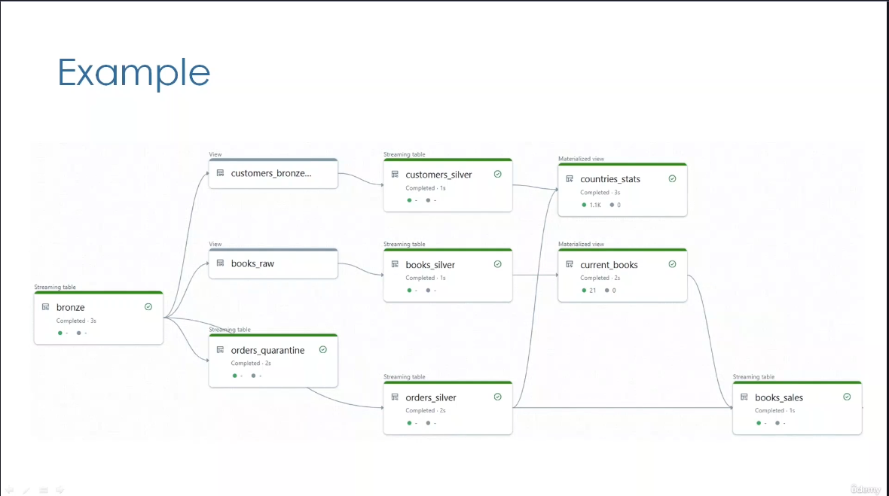

* LDP also automatically handles checkpoints, retries, and performance optimization.
* In addition, LDP makes it easy to implement advanced operations such as CDC processing, SCD type two updates, and data quality controls.
* In other words, LDP simplifies the hard work of building large scale ETL pipelines.

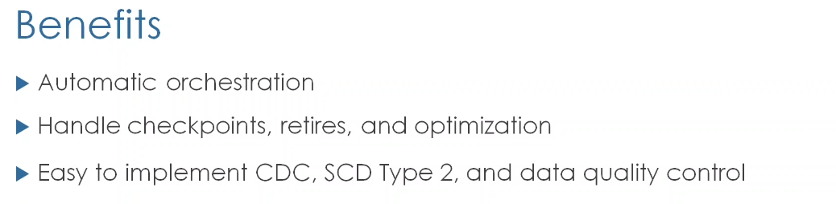

* Let us see this comparison to better understand the difference between spark and LDP.

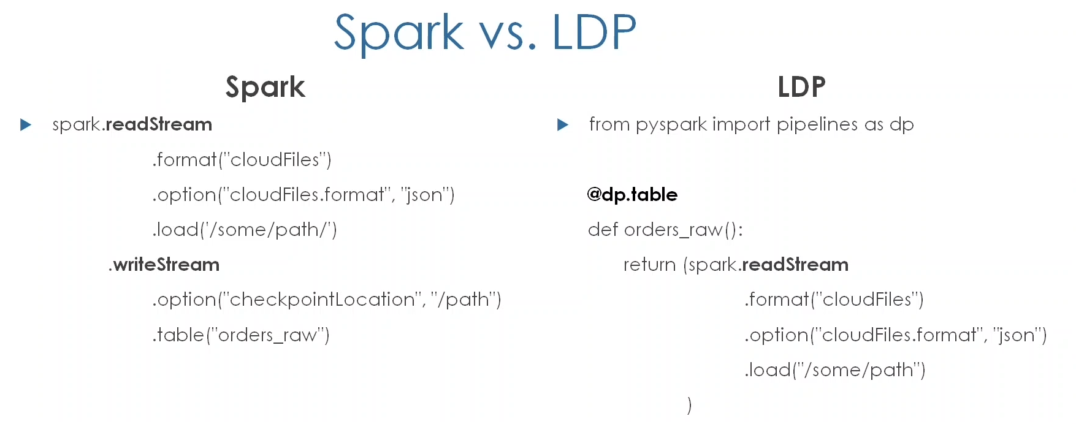

* LDP supports both **Python** and **SQL** syntax. Here we see the difference in their Python syntax.

|  |  |
| --- | --- |
| **Spark Structured Streaming** | **LDP (Lakeflow Declarative Pipeline)** |
| * Here we use **readStream** to read and **writeStream** methods to write into the streaming table. | In LDP this process is simplified using the **table decorator**.  As an example, we are not using the **writeStream** method in LDP to write our streaming table. Instead, the table decorator will be responsible for writing the table.  So, checkpointing is automatically managed by LDP |
| * **Regarding the SQL syntax**, in Spark Structured Streaming, **you cannot create Streaming tables in SQL syntax only**. You need to pass by PySpark API to register streaming table. | * On the other hand, LDP natively supports creating streaming tables in SQL via the **Create Streaming Table** command. |

* To create an object in LDP using the SQL syntax, we use this command - **Create or refresh an object followed by the object name**. In LDP, you can create 3 types of objects **streaming tables**, **materialized views**, and **temporary views**.
* In Python, you can create the same objects using the corresponding **function decorators**.

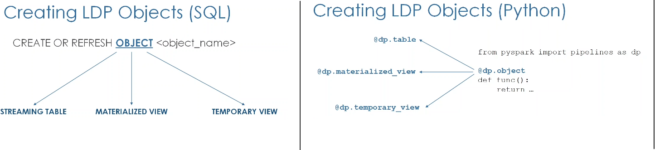

* Let us see this comparison to better understand the difference between these objects (LDP & Spark Streaming Table.
  + Both streaming tables are **Materialized Views**, are permanent object persisted to the data Catalog, while **Temporary views** are temporary objects scoped to the LDP pipeline they are part of, so they have not persisted to the Catalog.

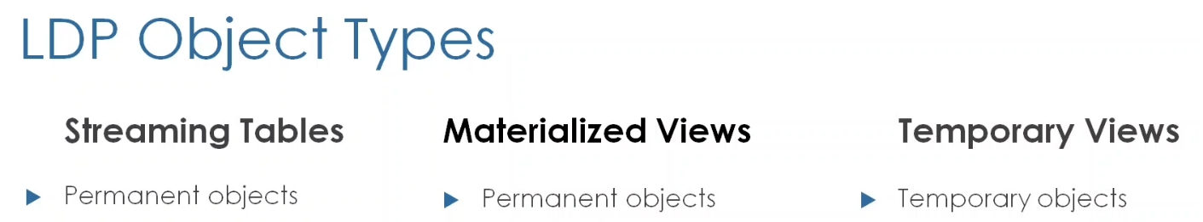

* + A streaming table is designed to handle data that is ingested incrementally, so each time the pipeline runs, we process only the new data that has been added since the previous run.

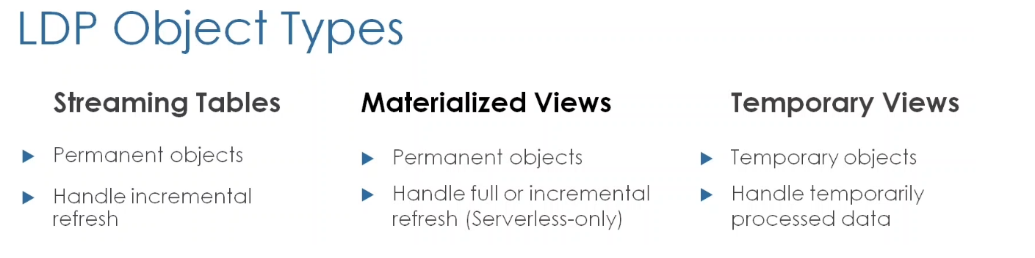

* + While a **Materialized View** handles data through full refresh processing, **where entire datasets are reloaded and replaced with each pipeline run**. However, **on serverless compute**, some queries can be optimized to incrementally refreshed, so it attempts to only process new or change data in the source.
  + **Temporary views**, on the other hand, handle temporarily processed data.
  + Streaming tables **support near real time data ingestion** from **append only** streaming sources like Kafka and Autoloader stream, or an **incremental append only** table that we read using **spark.readStream** method in Python OR via the **STREAM** function in SQL.
  + On the other hand, we use **materialized views** for pre-computing complex aggregations and joins from multiple large tables. For example, to accelerate BI dashboard performance.
    - They are also used for storing data from non streamable data sources. It means sources that contain data that has been updated, deleted or overwritten.
    - Remember, such datasets break the **append only** requirement of streaming sources.
  + Temporary views are used for **intermediate transformations** and **data quality checks** that we do not need to persist to a dataset.
  + Lastly, streaming tables support near real time data ingestion in the range of milliseconds, while materialized views are not designed for low latency use cases. So even though materialized view can support incremental refresh on **serverless compute**, the latency of updating them is in the minutes or seconds, but not milliseconds.

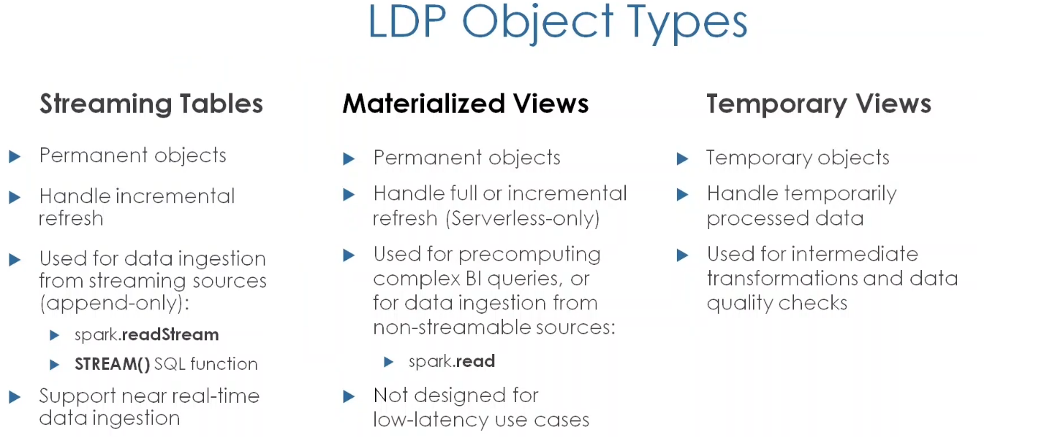

* For this certification exam, you need also to be familiar with the syntax used in the OLD DLT framework. Previously we used “**import dlt**” for module importing and the **table decorator** for creating either streaming or materialized views.
* The returned DataFrame determine the type, whether it was a streaming DataFrame i.e. **spark.readStream** method, or a static DataFrame **spark.read** method.
* While temporary views were created using the **view decorator** and NOT temporary view decorator.

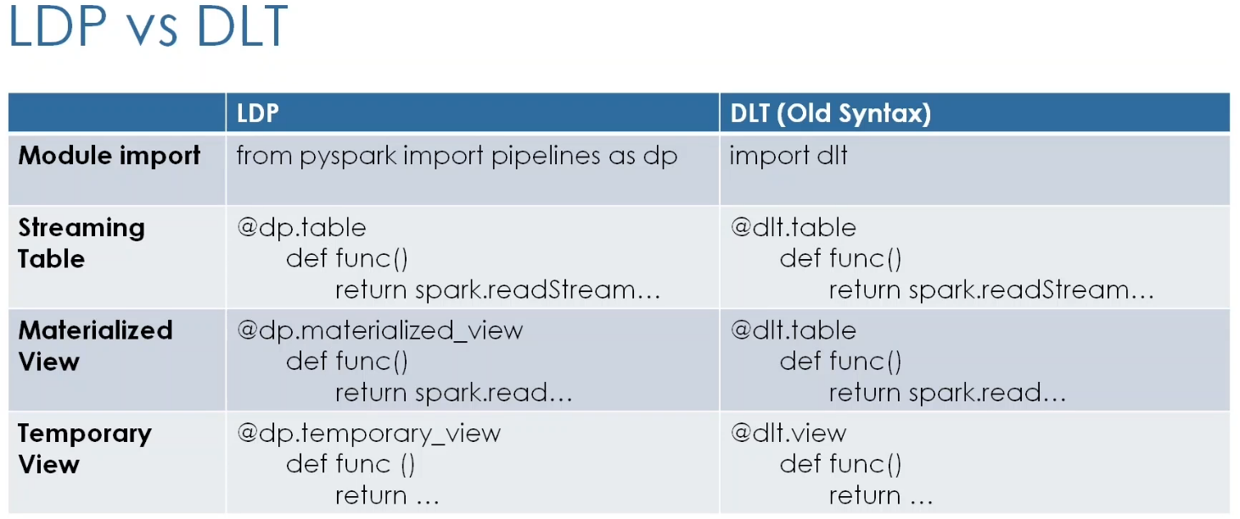

* DLT was based on notebooks, and we had the option to **validate** the source code using the validate button in the notebook.
* LDP on the other hand, is now based on script files with **.py** or **.sql** extension, and we have the option to perform a dry run to validate our pipeline source code without updating any data.

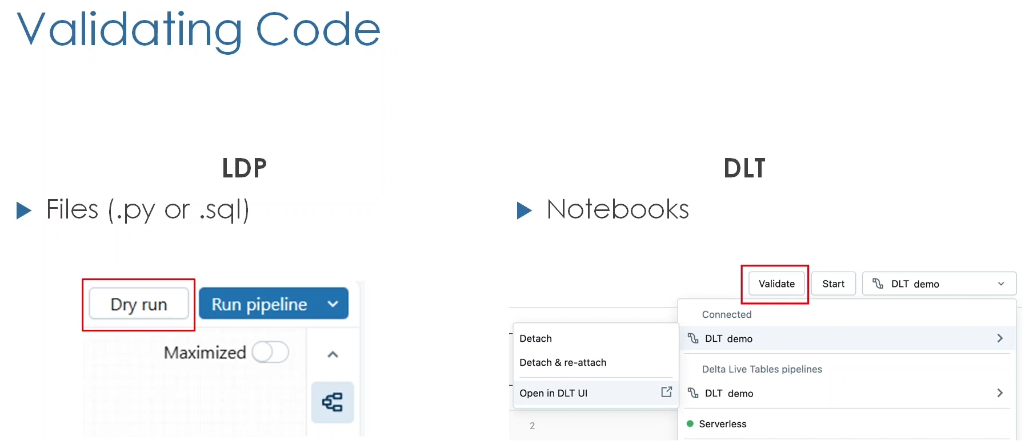

# Lakeflow Spark Declarative Pipelines (Hands On)

* Here, we will rebuild our **bookstore** project using lake flow declarative pipelines or LDP.
* We are going to refactor our PySpark code to align with LDP's declarative style.
* Here, we will focus on data ingestion by creating our multiplexer **bronze** table as a streaming table and the **country's** lookup as a temporary view.

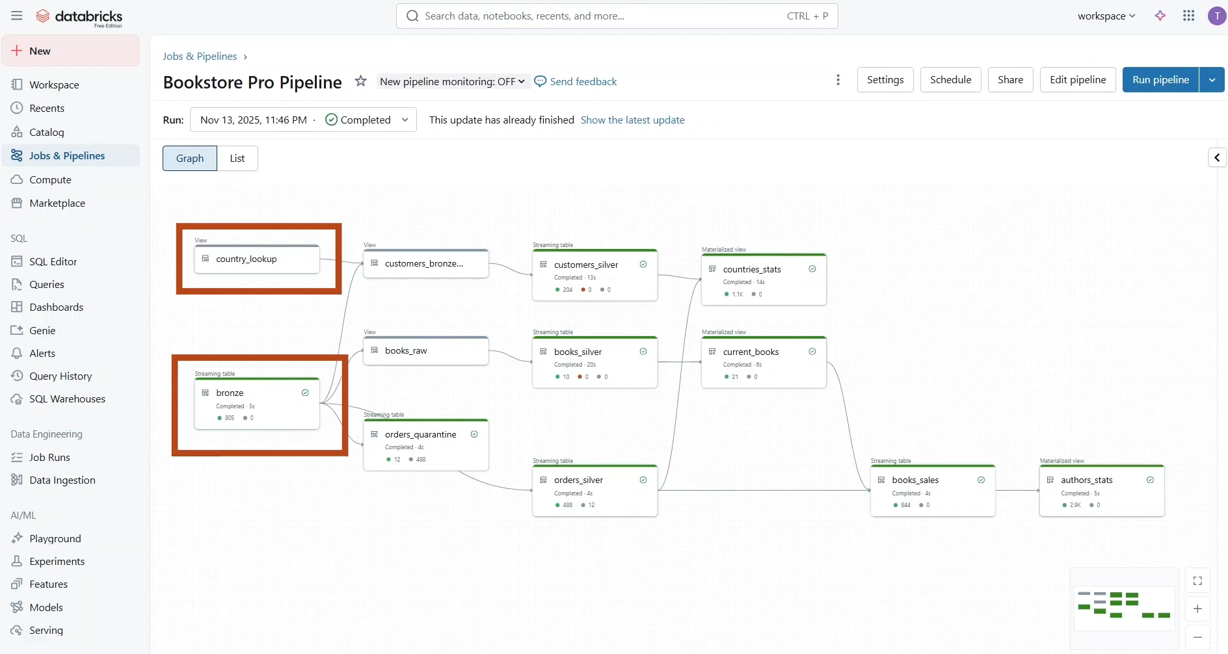

* To create a new pipeline, start by navigating to **Jobs & Pipelines** in the sidebar, then create ETL pipeline.

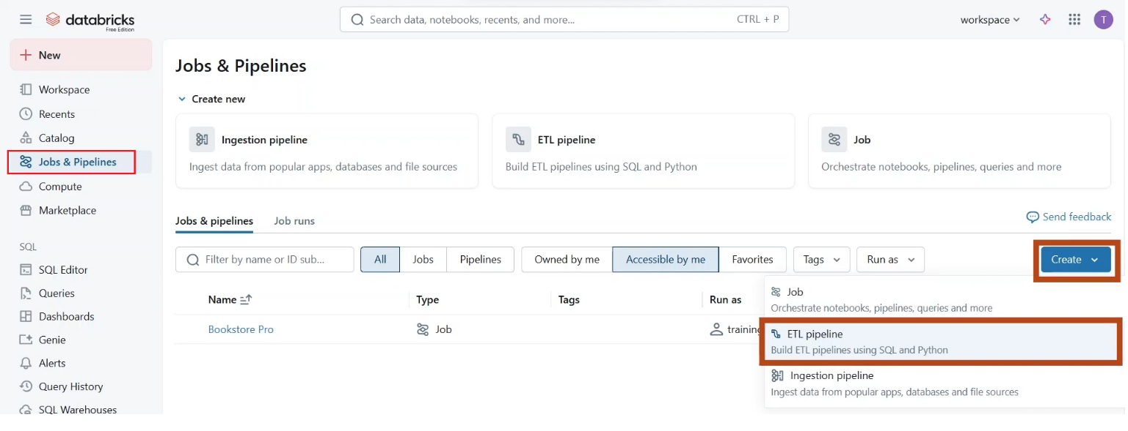

* Give your pipeline a name like **Bookstore Pro Pipeline**. From here, you can select your default Catalog and schema or create a new one.

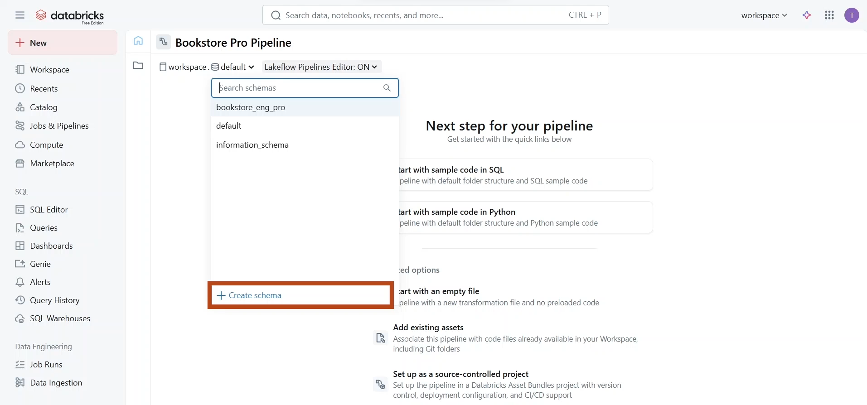

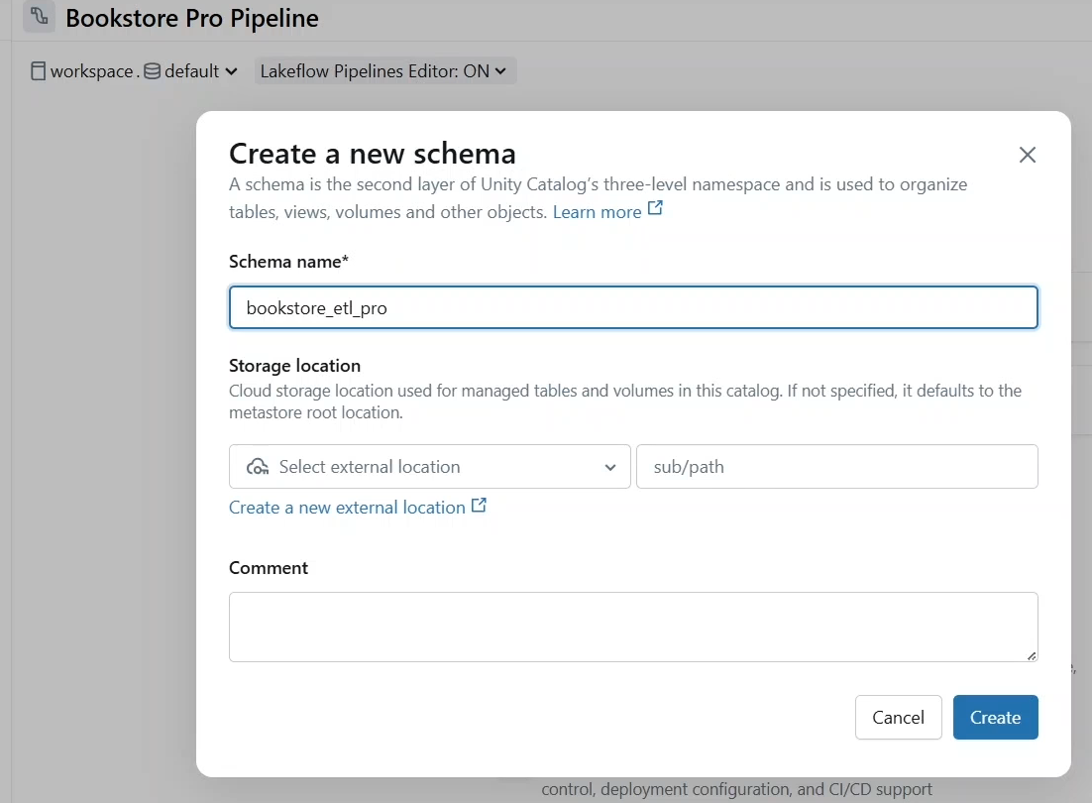

* Let us create a new one called **bookstore_etl_pro**.
* As you can see, you can **Start the sample code in SQL** or Python, **Start with an empty file** or open **Add existing assets**.

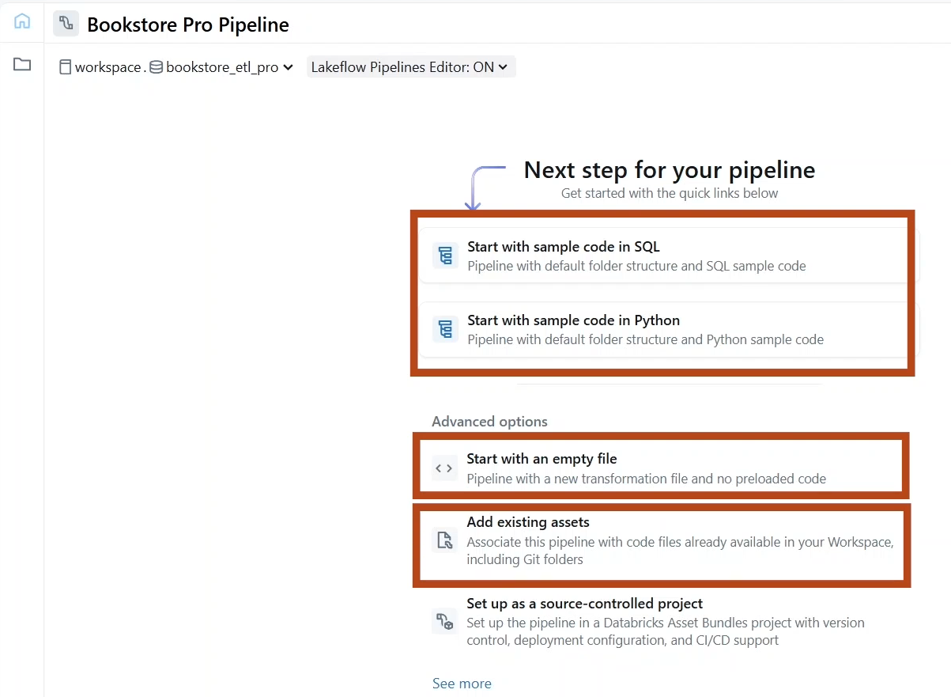

* Let us click “**Start with an empty file**”. Choose a **destination folder** for your source code files. And click select.

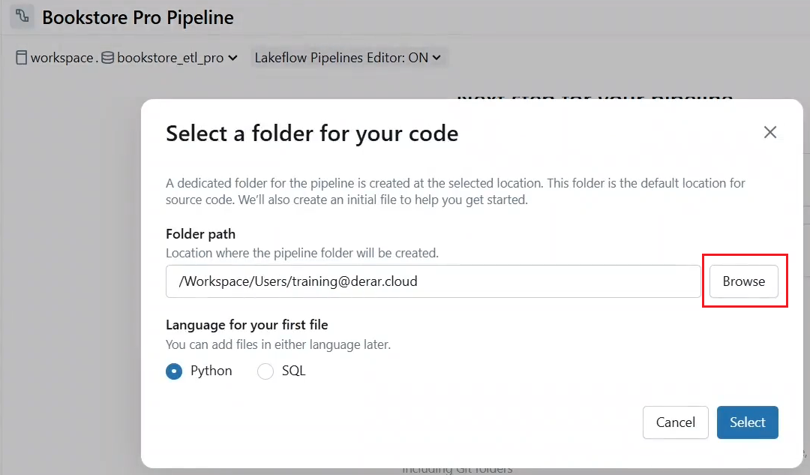

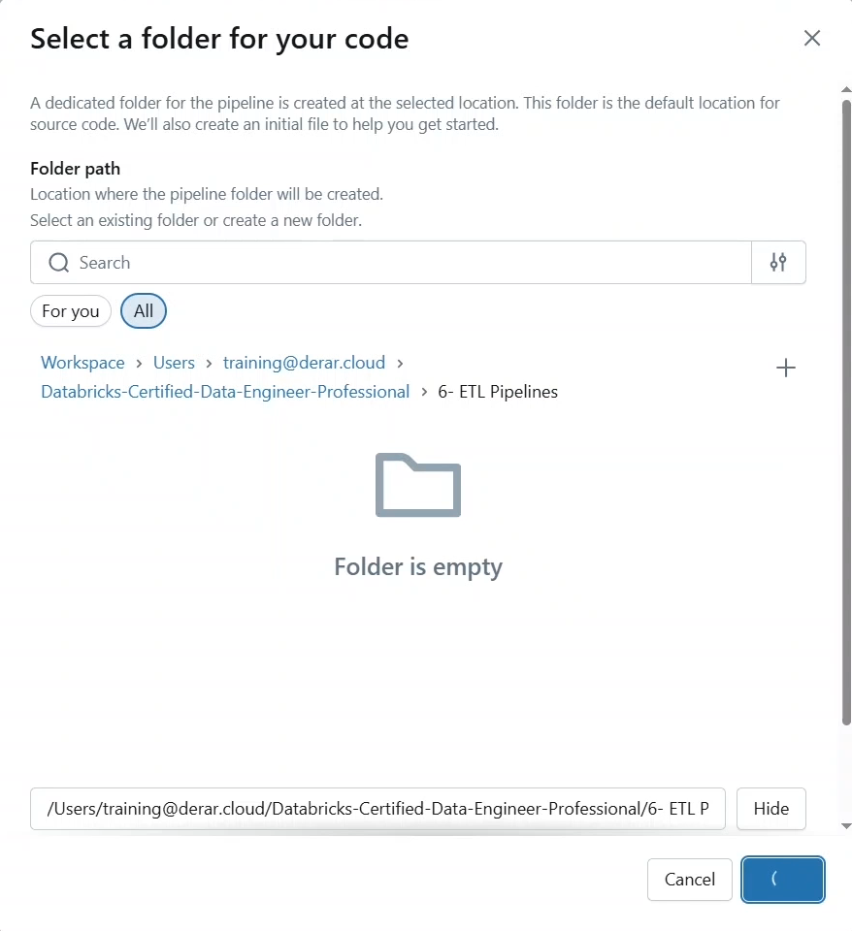

* Here is our pipeline editor. On the left you can see the **Pipeline Asset browser**, where you can organize the pipeline files to get more space on the screen.
* We can hide the left sidebar. In the middle, the code editor.
* On the right, you will have your **pipeline visualized as an interactive graph**, on top the toolbar to **run, share, schedule**, and **configure** the pipeline.
* At the bottom you can preview your **Tables** and their **Performance**.

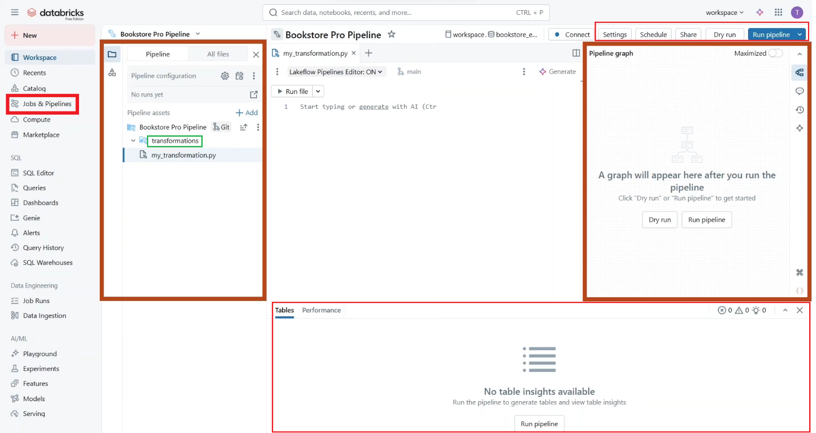

* In the **Pipeline Asset browser**, a default folder structure is created with a directory called **transformations** to store the source code files.
* If you want, you can rename this folder.
* In addition, you can “**Add**” additional source code directories to further organize your code.
* You can also add other directories like explorations for source code files, such as notebooks used for exploratory data analysis.

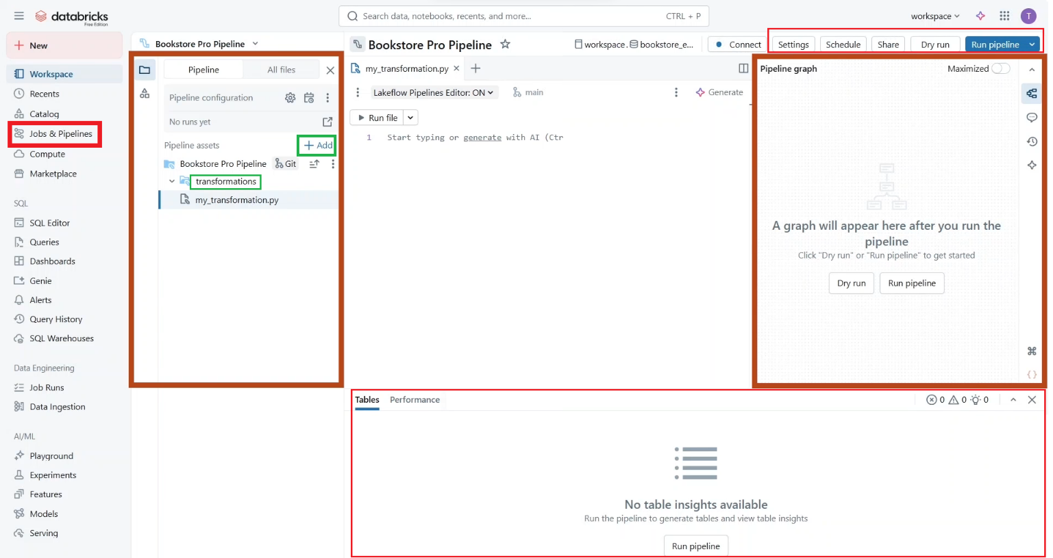

* As you can see, this file is excluded from the pipeline source code, but you can click here to include it “**Include as pipeline source code**” if you want.
* You can also switch these at the folder level.

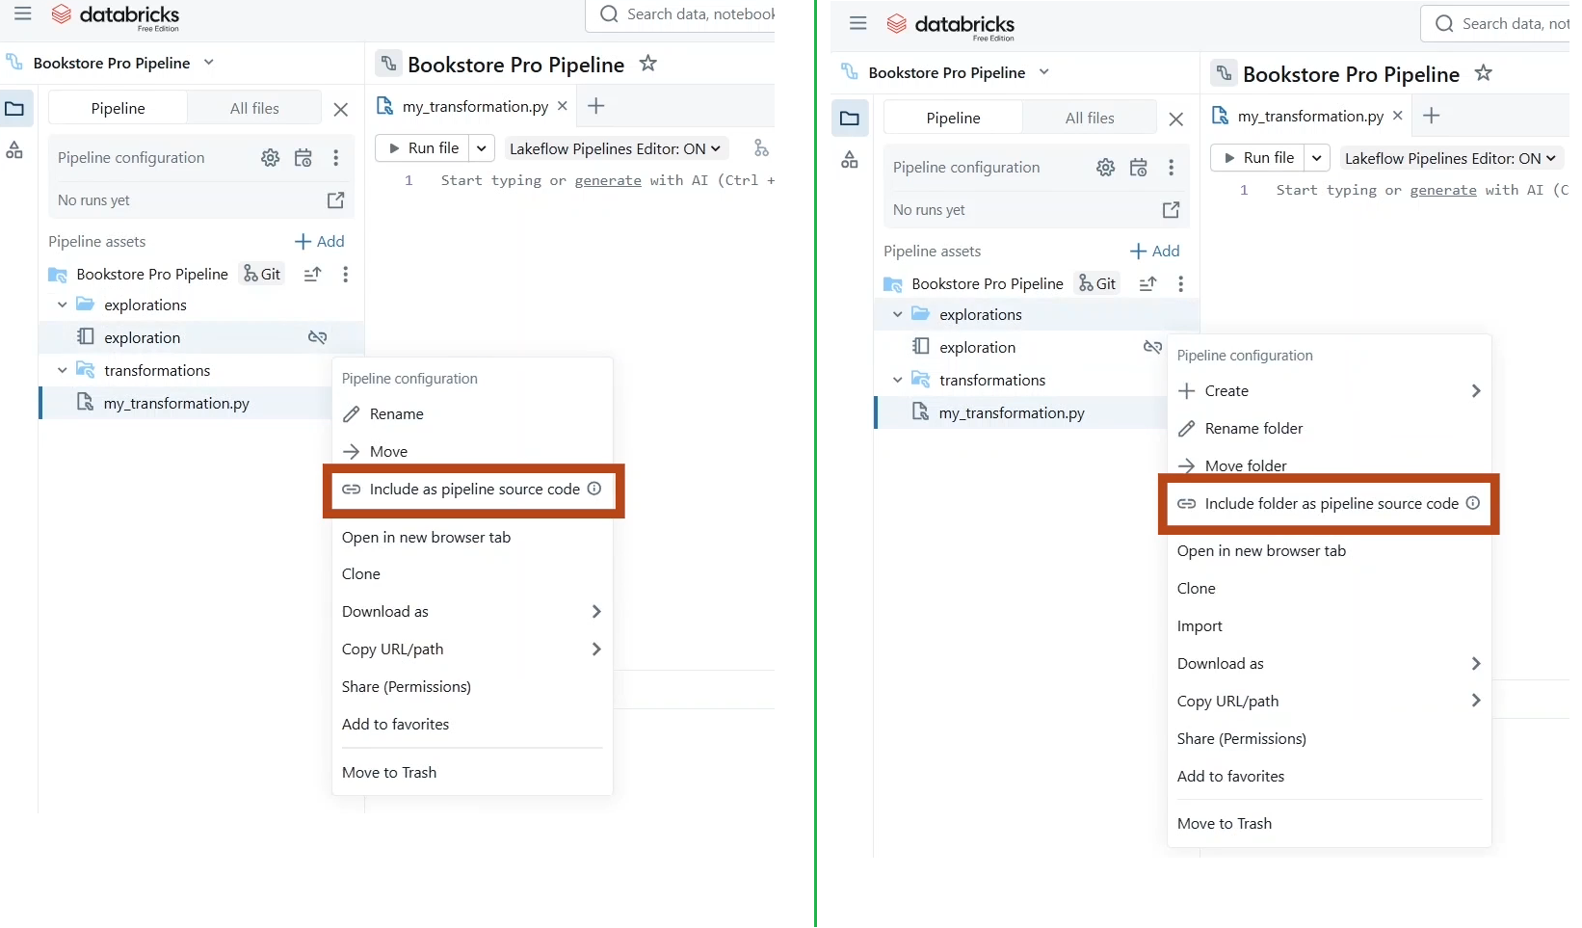

* Let me **add another notebook** here for exploring our data set. Here I will just run the “**Copy-datasets**” helper notebook. And print the dataset path.

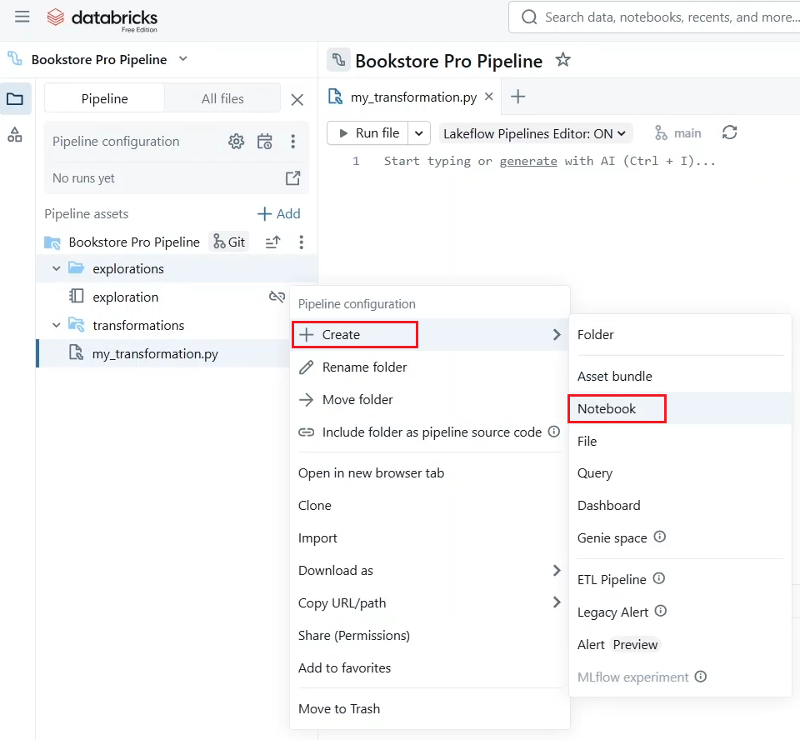

* As you can see, this path is for the dataset volume in our bookstore schema.
* Let us copy this path and see how to configure it for our pipeline.

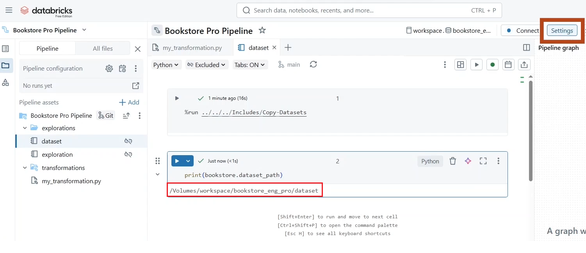

* For this, click on the “**Pipeline settings**” button.
* From here you can configure your pipeline such as the **pipeline mode**, whether it is **triggered** or **continuous**.
* Triggered, meaning incremental batch mode like the “**Available Now**” trigger mode in Spark Structured streaming. In other words, the pipeline runs once to process all available data, then shuts down until the next manual or scheduled execution.
* While in **continuous** mode, the pipeline runs continuously to process incoming data at a regular interval. For example, every two seconds. For this demo, let us keep it triggered.
* You can also edit your **Catalog schema** and **compute type**.

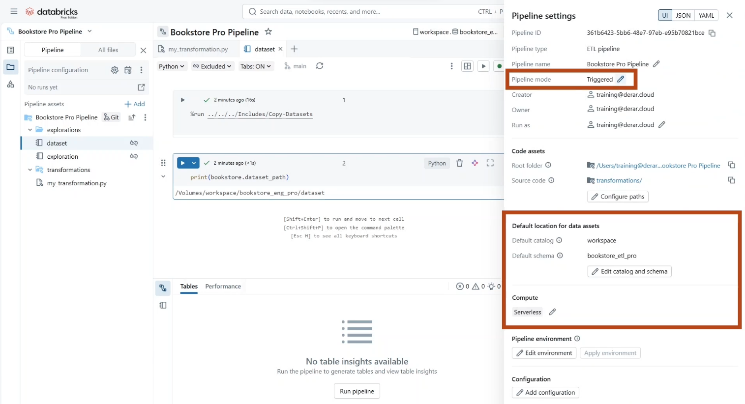

* Under **configuration**. We can **add key value parameters** like **dataset path** to define the source directory of our dataset. Click **save**.

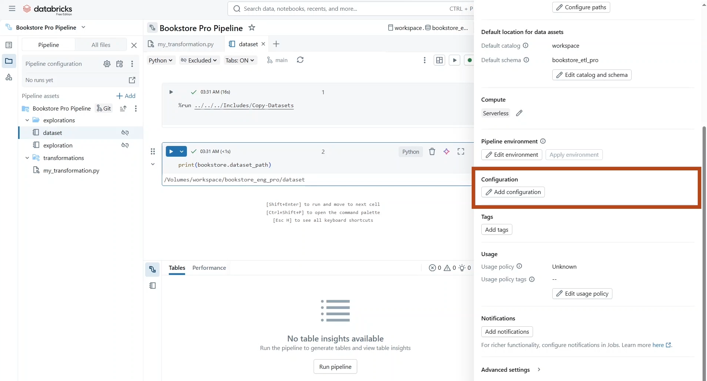

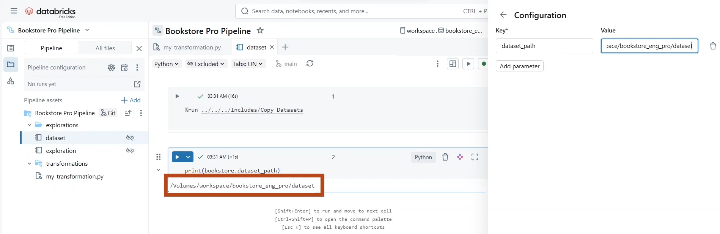

* In addition, under **Advanced settings**. You can define a table to store the event logs of the pipeline.

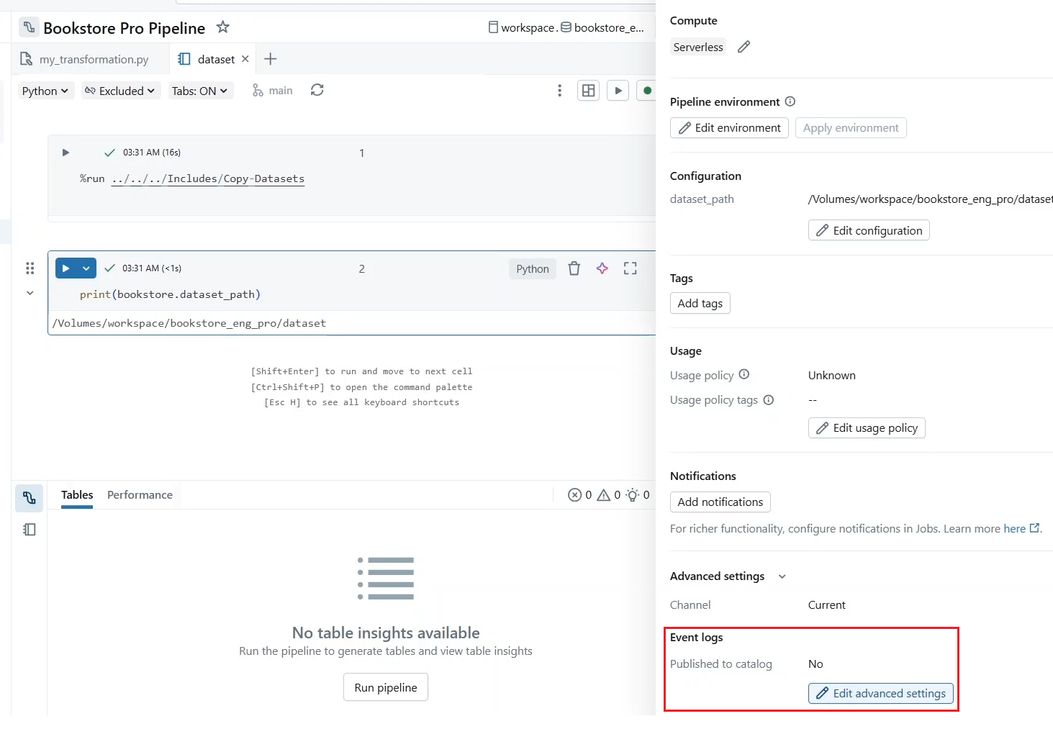

* Let us define one in our bookstore ETL schema and we will explore it in the next lecture.
* Now click **Save**.

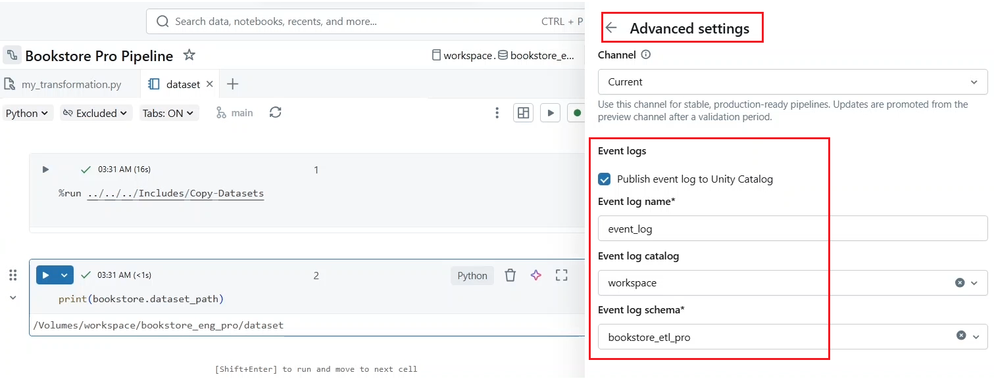

* And close this **panel** as well as **dataset** notebook.
* As you can see in the asset browser, there is an empty Python script file with a default name “**my_transformation**”. Let us rename this file to “**1_data_ingestion.py**” and start developing our pipeline.

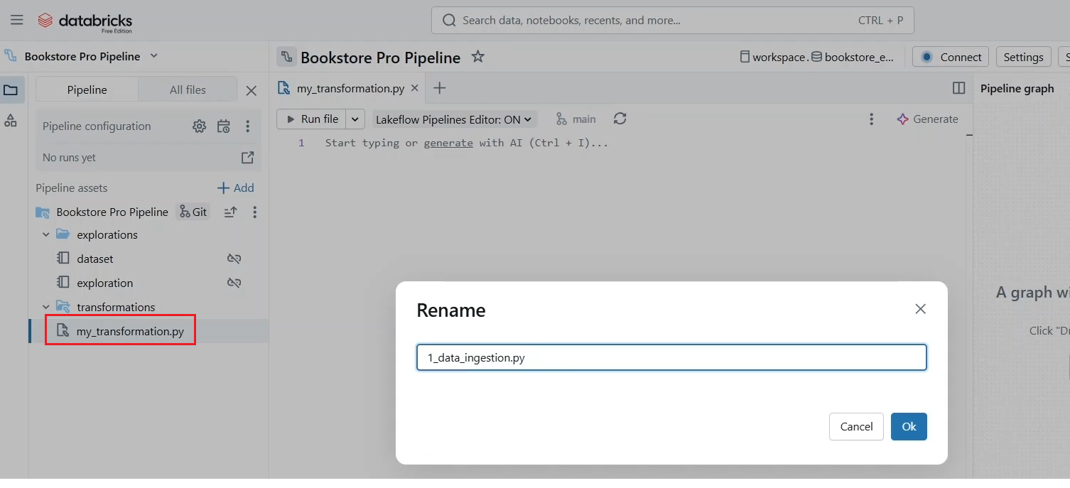

* First, we need to import the **pipelines** module from PySpark. In addition to the **functions** module.
* Next, we read the **dataset path parameter** that we defined previously in the pipeline settings.
* With this, we can proceed to create our first object, which is **the multiplex branch table**.
* We will create it as a **streaming table to support incremental data ingestion from an autoloader stream**.
* These functions define an autoloader stream and return a streaming data frame.
* Notice that we don't perform a streaming write in LDP. These will be automatically handled by the **table** decorator.

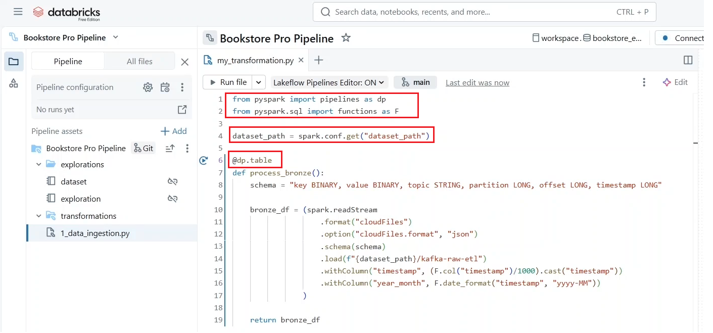

* By default, the table name will be the same as the function name, but if you prefer, you can add the name parameter to the decorator function to specify a different table name.
* The table will be created in the default Catalog and schema that you define in the pipeline setting, but you can use the 3-level namespace to persist your object to a different Catalog or schema. For example, you may have a schema for each layer bronze, silver, and gold.

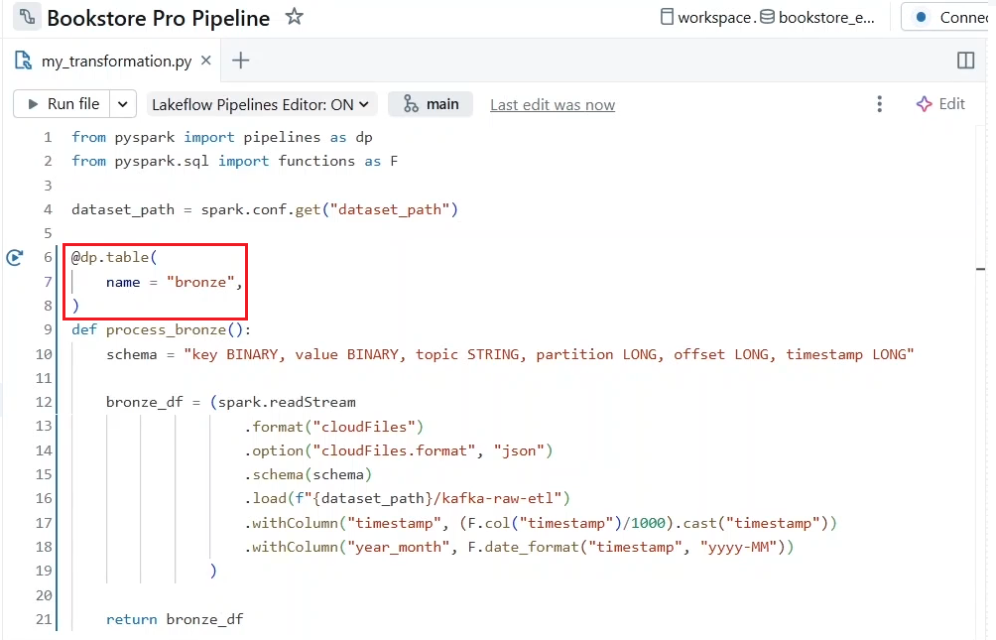

* Moreover, in the decorator function, you can add additional parameters to configure your table like the partitioning columns and table properties.
* For example, you can add the **delta.appendOnly** property to disable updates and deletes on this bronze table.

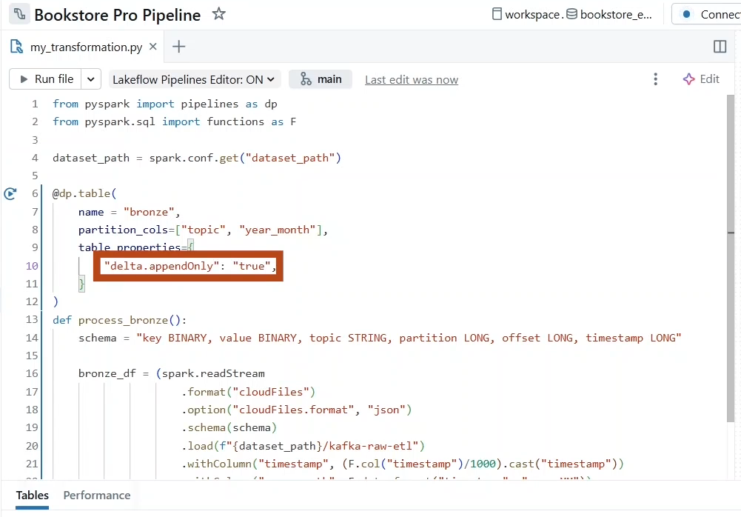

* Also, you can set the table property **pipelines.reset.allowed** to **false** when running your pipeline.

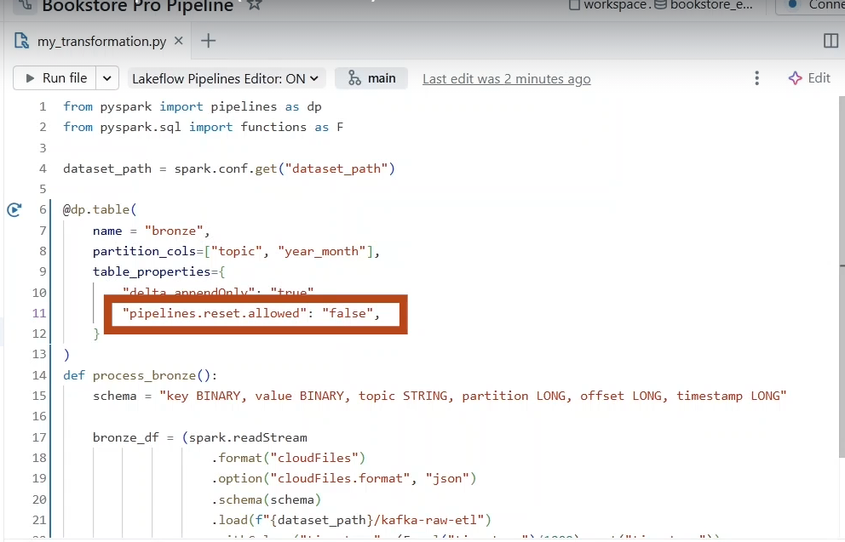

* + You also have the option to reset all tables using a full refresh to start from scratch, but usually you don't want to reset your bronze table as it represents your source of truth, and the source data could be no longer available due to short retention periods in the source system like Kafka, for example, which has a default retention period of one week.
  + So, setting this table property ensures that the data in this table and its checkpoint will not be affected by a full refresh.
* In addition, we can **create temporary views** simply by using the **temporary view decorator**.
  + Here we are creating a temporary view to lookup country information, which will be used in a joint operation in the next lecture.
  + Before running our pipeline, let us perform a **dry run**. These will check the validity of the source code without persisting the results.
  + Here we can confirm that our objects are correctly defined. However, with the dry run, the bronze table is not yet created until we perform an actual pipeline run by clicking **Run Pipeline**.

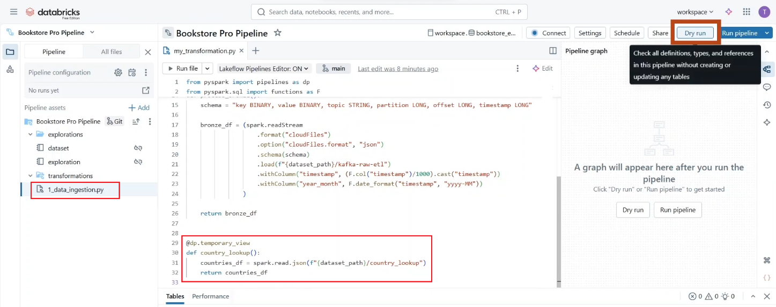

* Let's click the “Run Pipeline” button.

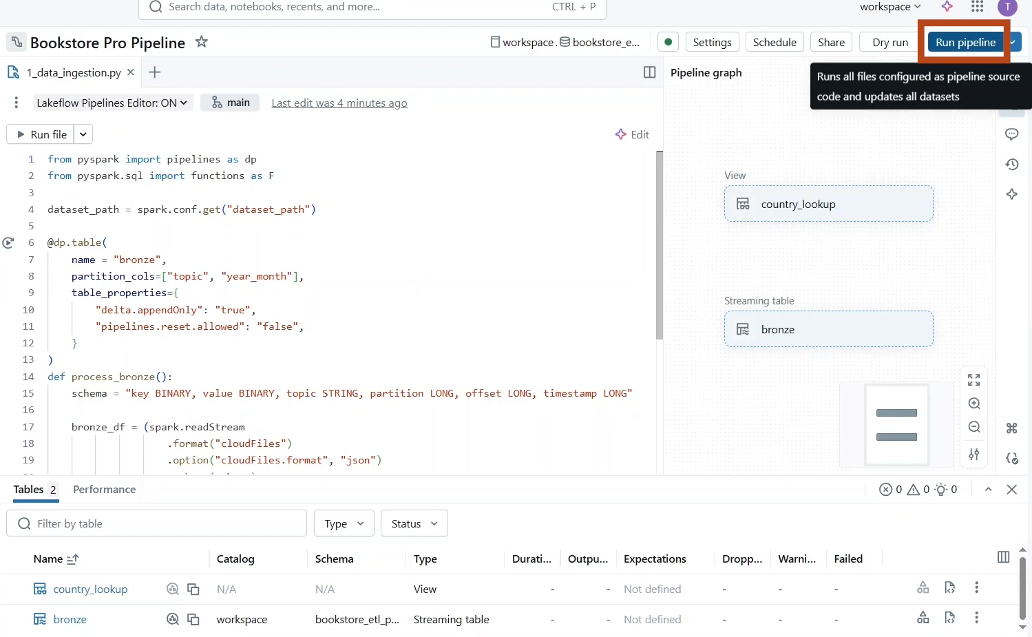

* Our pipeline run has been successfully completed.
* If you click on the table (i.e. bronze table), you can explore its data, but the result here is a **truncated.** As you can see, we processed more than 1000 records to know the exact number of records. Let us use the **exploration** notebook.

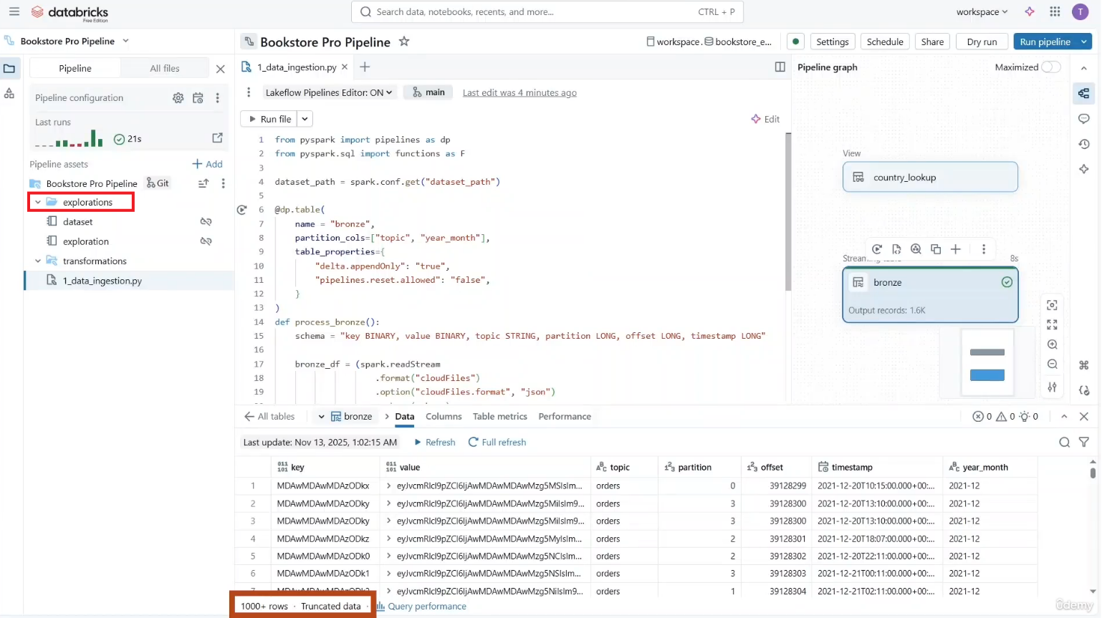

* Let us remove the sample query and replace it with the record counts of our bronze table. Let us now run these two cells. As you can see, there are **1621** records in the bronze table.

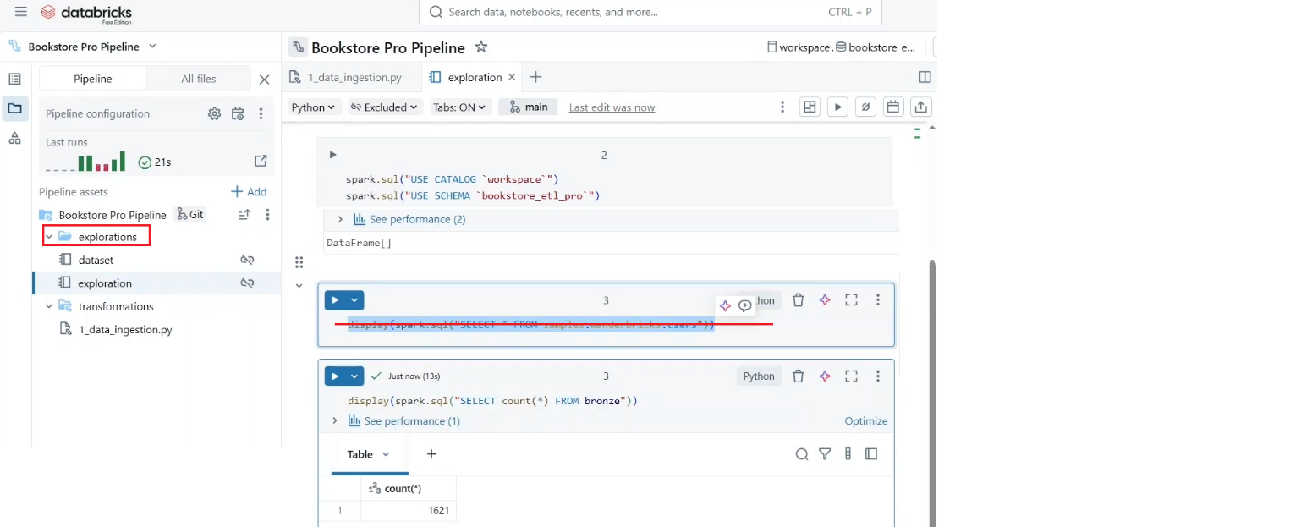

* Notice that the pipeline compute is still running.

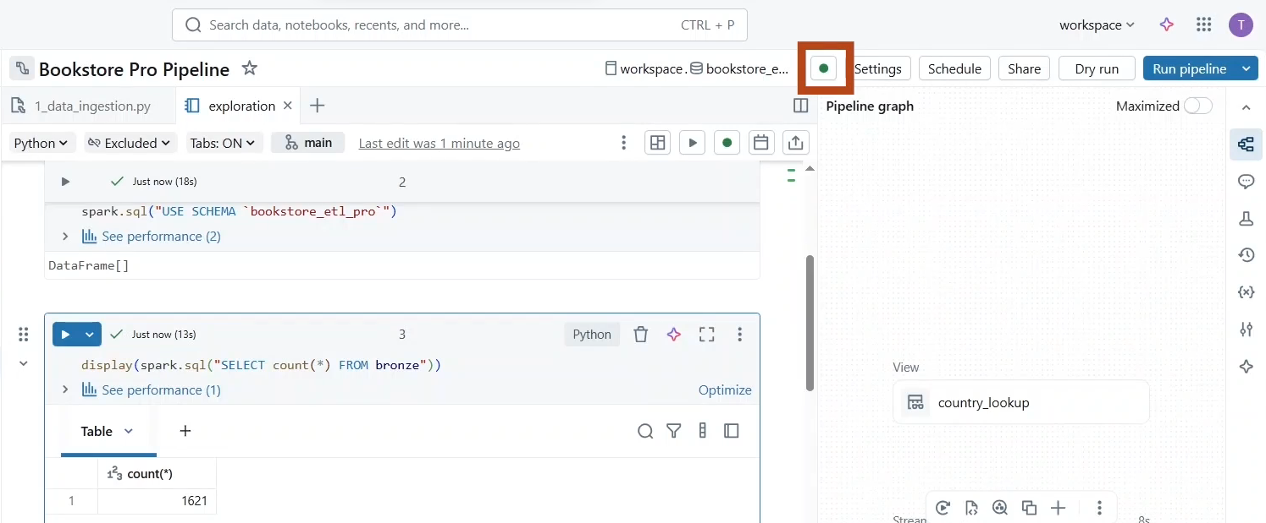

* This is because the pipeline runs in **development mode** while we are here in the pipeline editor. This mode reuses the same cluster for 2 hours to avoid the overhead of restarts.
* Also, it **disables automatic retries** that usually we have in production mode to quickly detect and fix errors.
* You can run the pipeline in **production mode** by clicking “**Run now with different settings**” and disabling the development mode.

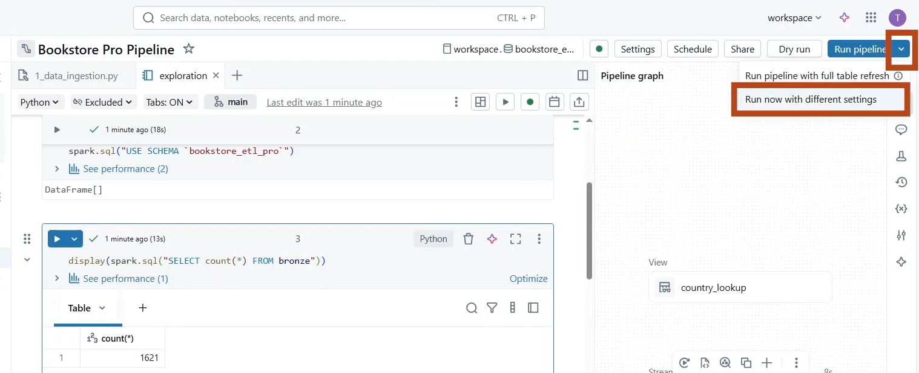

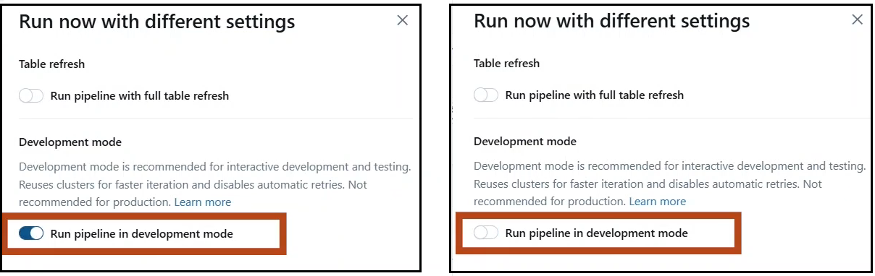

* The **production mode** **creates a new cluster for each pipeline run** and **automatically retry execution in the event of specific errors**, such as a failure to start a cluster, memory leaks or expired credentials.
* Let us cancel this.

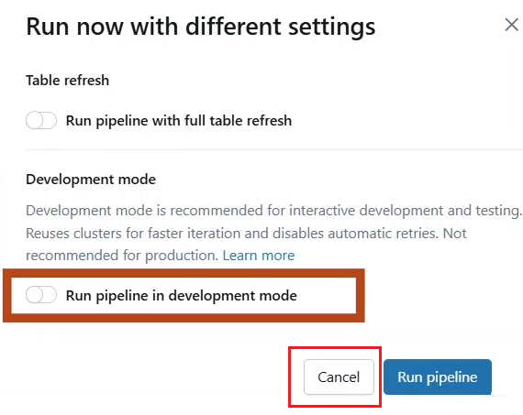

* You can also click on the **last runs** to **open** the **pipeline monitoring page** and **run the pipeline** from here.

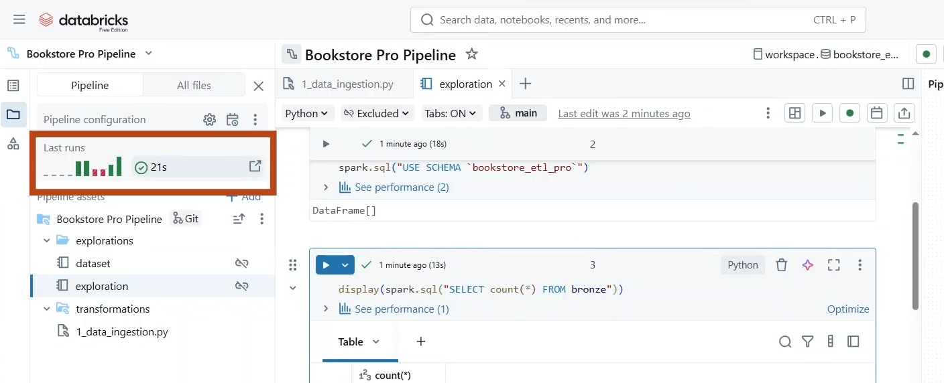

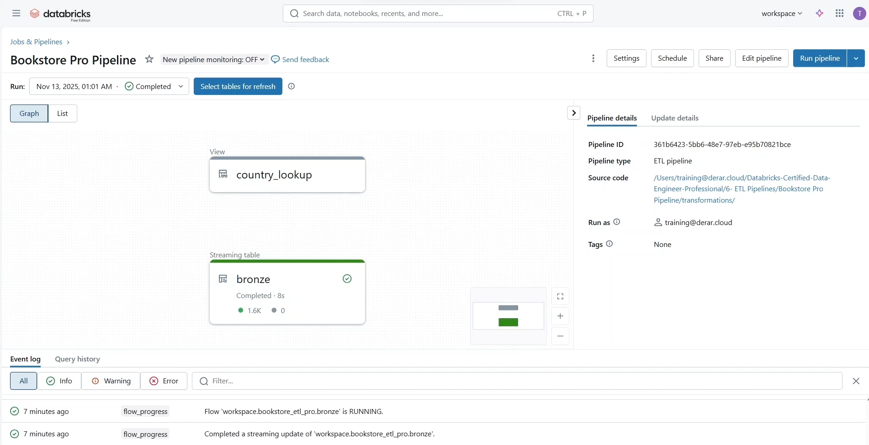

* Running the pipeline in the monitoring page defaults to the **production mode**, but you can change it from the **settings** menu under **Advanced Settings.**

